*Florida International University*

*School of Computing and Information Sciences*

Software Engineering Focus

Feature Document

User Story ID 777

**Name:** Multiselect Sub-Users

**Team Member(s):** Leandro Gonzalez,Luis Herrnsdorf

**Project:** Smart Stormwater (Smart City System) 2.0

**Product Owner(s)**: Emilio Lopez

**Mentor(s)**:

**Instructor**: Masoud Sadjadi

**User Story Name:**

* Description: As an admin, I want to be able to multi-select users on the Sub-Users page, so that I am able to assign devices to multiple users at the same time

Acceptance Criteria

* An ‘Actions’ dropdown appears in the header of the Users List table of the Sub-Users page
* The ‘Actions’ dropdown contains a ‘Multiselect’ checkbox and a button ‘Assign Devices’
* Checking the ‘Multiselect’ checkbox adds a Selected column (with a checkbox) to the Users table, and hides the ‘Devices per User’ table
* Clicking on ‘Assign Devices’ brings up the floating window containing the devices assigned to the logged in user. Admin multi-selects devices, and can either click on assign or cancel
* Selected devices are assigned to all selected sub-users, and changes are saved to the database

**Use Case**

* Name: Multiselect sub-users
* Actor: Admin
* Preconditions: Admin is logged in, admin as sub-users
* Description: On the ‘Users’ page, the admin clicks on the ‘Actions’ dropdown on the top right corner of the ‘Users List’ table. The admin checks the checkbox ‘Multiselect’, and a new ‘Selected’ column appears on the Users table (with all users unselected by default). The Admin selects multiple sub-users by checking the ‘Selected’ column. Admin clicks on the ‘Actions’ dropdown again, and then clicks on the ‘Assign Devices’ button. A floating windows comes up, showing all devices assigned to the admin. Admin multi selects devices and clicks on ‘Assign’. The floating windows closes after the selected devices are assigned to all the selected sub-users.

**Use Case Diagram**

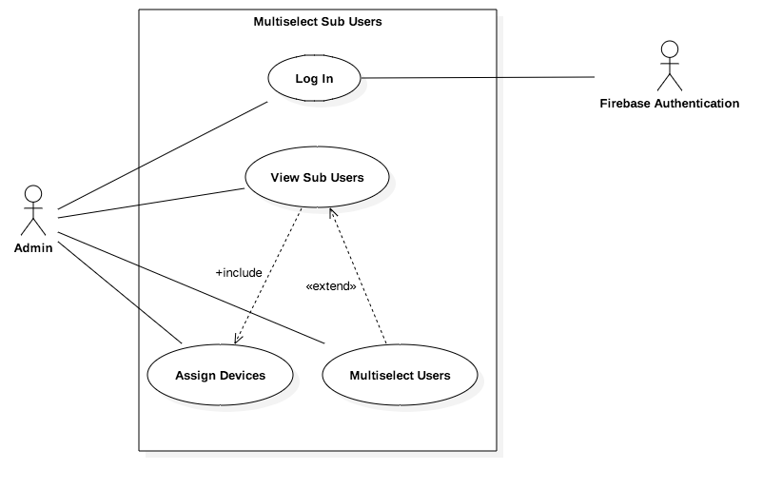

**Sequence Diagram**

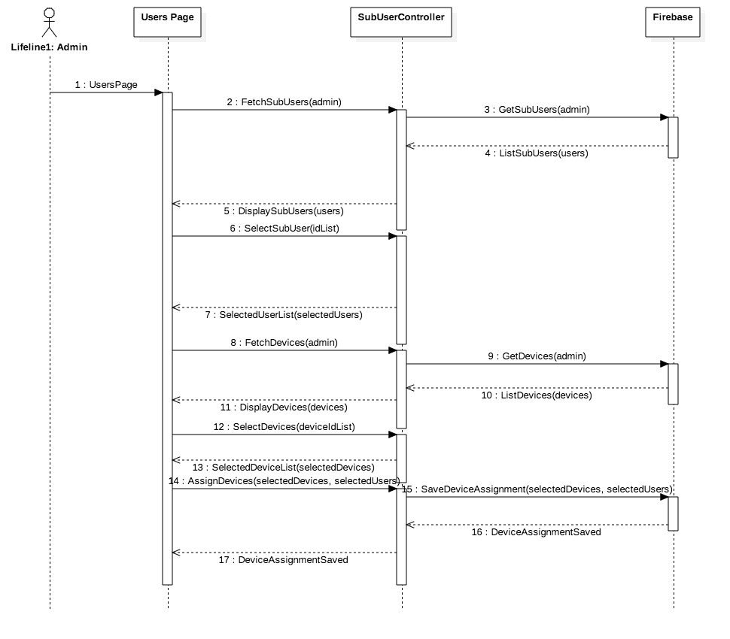

**Class Diagram**

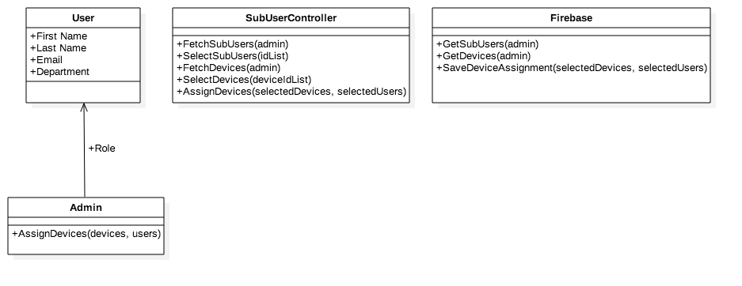

**Unit Test**

* Test case ID: MultiselectSubUsers001
* Description/Summary of Test: Admin selects multiple sub-users and assigns devices to them
* Pre-condition: Admin is logged in, admin has sub-users
* Expected Results: Admin assigns devices to multiple sub-users at once
* Actual Result: Devices are assigned to all the selected users.
* Status (Fail/Pass): Pass

**Visual User Guide**

